**HOMEPAGE**

Purpose:

* Show most of the features of website, namely:
  + Banner : Show the logo of website, maybe some advertisements or event (bigsale) of website.
  + Brand bar: show the logo of brands that website sale sneaker of this brand. When we click to any logo of brand, the website will navigate to “Brand” site, this site will be explained in below part. Beside that, we can see it all when click on “Xem tất cả” button.
  + New (Giày mới): Show newest sneaker of website (image, name and prize), when we click on any sneaker, the website will navigate to site that show all information of this sneaker, this site will be explained in below part.
  + Bestseller (Bán chạy): The same with “New”, showing sneaker that are sold most.
  + 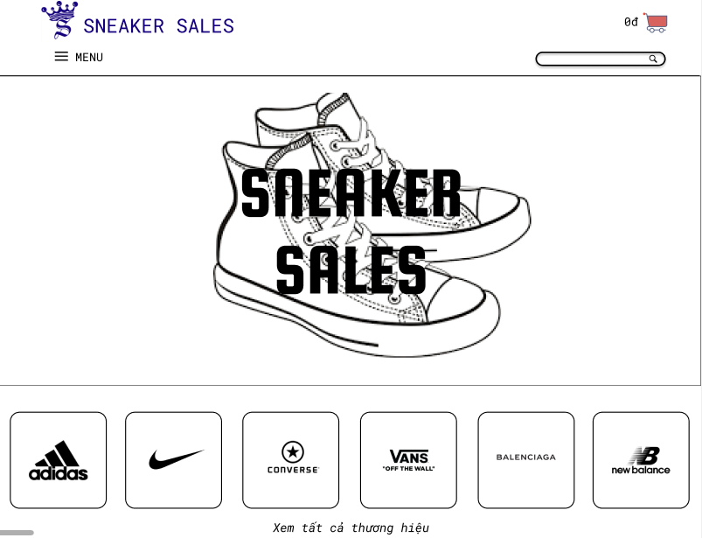Collection (Bộ sưu tập): Showing some highlight collection, we can see it all when click on “Xem tất cả” button. Besides that, we can see one collection by click to its logo. The site “Collection” will be explained in below part.

BRAND

BANNER

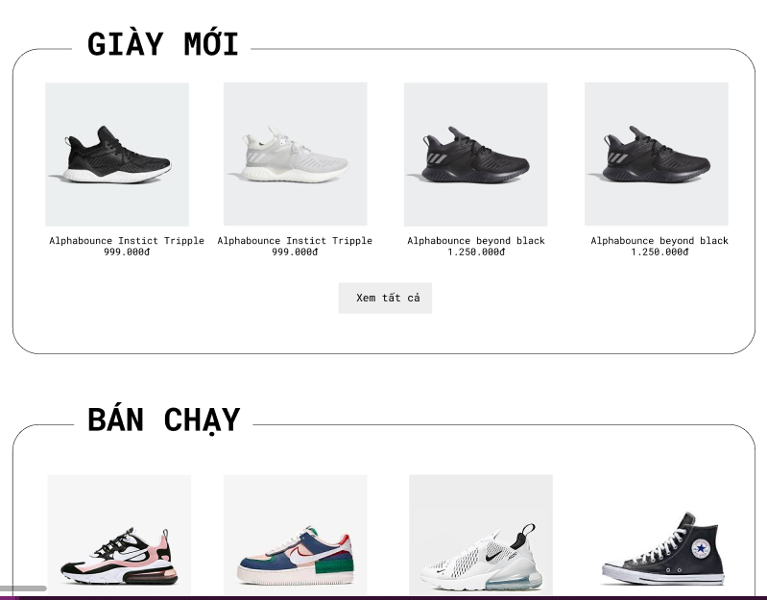

NEW SNEAKER

SEE ALL

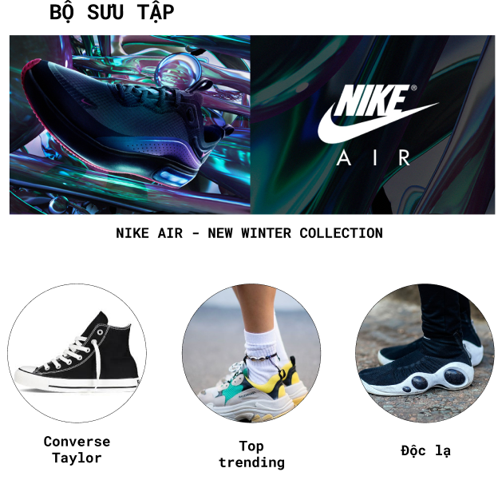

SOME COLLECTION AND ITS NAME

COLLECTION

BESTSELLER

**BRAND PAGE**

**Purpose:** At this page, users can make search through choosing brands that we have on shop by clicking BRAND squares classifiedly. Also they can make purchases at this phase by go onto direct details of prods through clicking directly prods’ imgs n check this at shopping cart symbol on the right top of page.

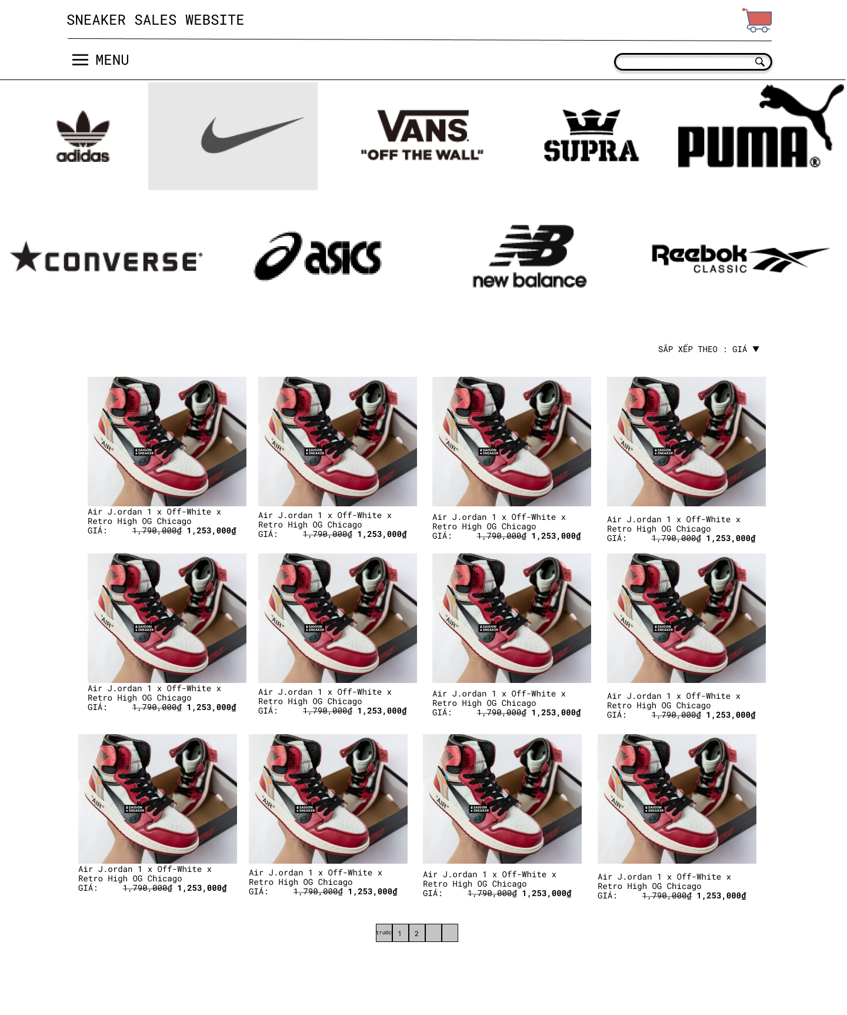

Choose brand

**COLLECTION PAGE**

**Purpose:** This page has same usage and descriptions to BRAND page except one thing that products are classified by our collection, collection can include brand or some collection of this brand.

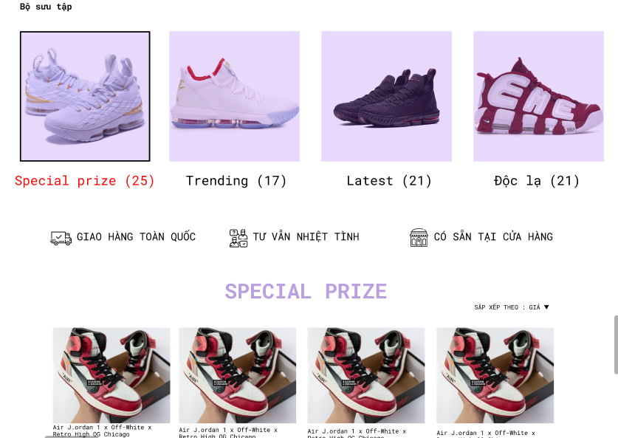

**SEARCH RESULT PAGE**

**Purpose:** At header bar, we have a search bar, and the result when we typed some thing in it is this page. Basicly, this page show the result (sneaker) in searching process, we have some advanced search and filter. Tthis page includes some part below:

+ Result input: The text that you typed.

+ Number of result: if the total of result is less than or equal with 12, it will show “Hiển thị tất cả kết quả”. If the total of result is more than 12, it will show a text like “Hiển thị 1 – 12 trên tổng số 120 kết quả”.

+ Filter: The result is sorted by prize or date, comment, ….

+ Advanced search: The result will be searched again by some criteria like gender, color, size, brand, prize, …

+ Result: Showing result (logo, name and prize).

+ Pagination: Paging if the total of result more than 12.

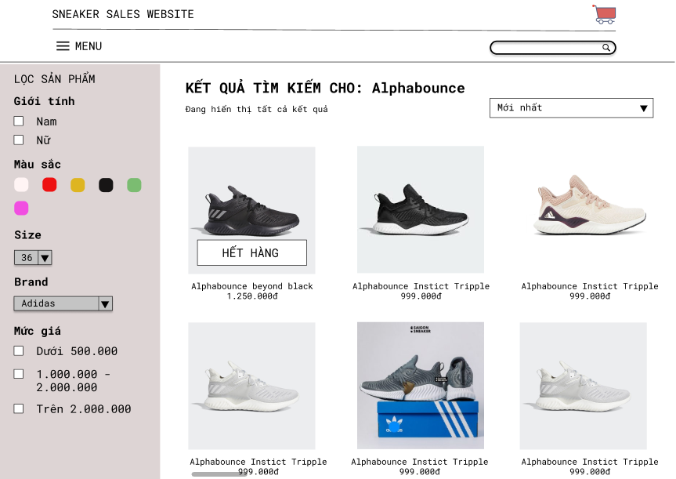

Result

Advance search

Number of result

Filter

Result input

**SHOPPING CART PAGE**

**Purpose:** The Shopping cart website helps customers contain products that customers choose to prepare for the checkout process:

Customers can add products to the cart through the product detail page.

* Customers can delete products in the cart by clicking the x before the product.
* Custemers can adjust the quantity of products by clicking the quantity adjustment of addtion or subtraction.
* Each time to update the cart, customers will click on the button “Cập nhật giỏ hàng”

After completing the steps of adjusting cart:

* Customers can add a promo code in the promotion code box and click “ Áp dụng”
* There will be a summary of the information of the shopping cart sush as price, delivery method.
* If there is no questions and any amendments, the customer can go to the order page via the button “ Tiến hành thanh toán”

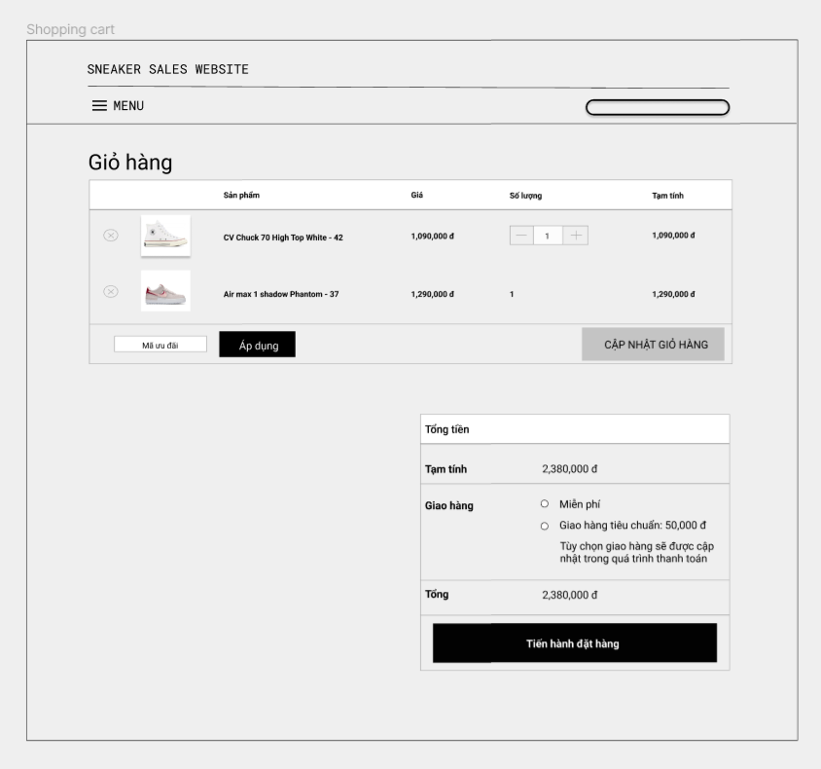

**ORDER PAGE**

**Purpose:** After completing the step to select products, customer can process to payment

* Customer can login to the system in order to stored point.
* Customer can add a promo code.
* Customer must fill in all the information needed such as Name, Phone number, address annd email.
* Customer can take notes about their products in the note box.

After filling all the information needed:

* Customer must choose delivery method and payment method.

If there is no changes, customer can press the “Đặt hàng” button to finish the process and wait for the comfirmation of the shop.

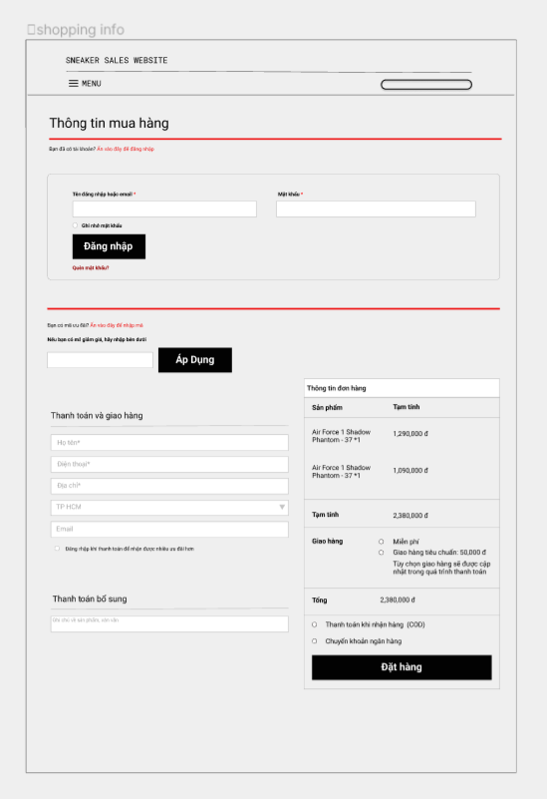

**HEADER**

included menu search bar and cart icon.

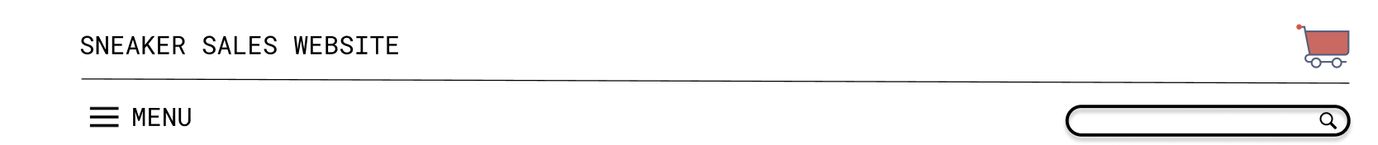

Menu: use to navigate between page.

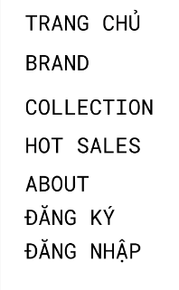

Search bar: user can search product here, after that the search results page would open.

Cart icon: use to open the shopping cart page.

**SALE**

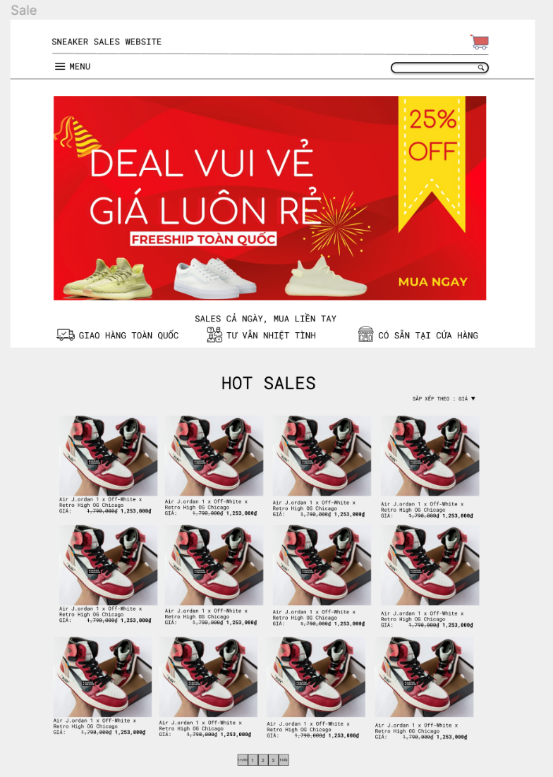

**The purpose:** User can look for all hot sales product in this page. There are also information of the newest promotions included.

First part of this page is where the promotion stay, user can view the promotion easily.

Second part of this page is where all the hot sales product stay, user can click into the product image to view the detail of that product.

There will be a pagination at the end if there a lot of hot sale products and a sort button at top right.

**DETAILS**

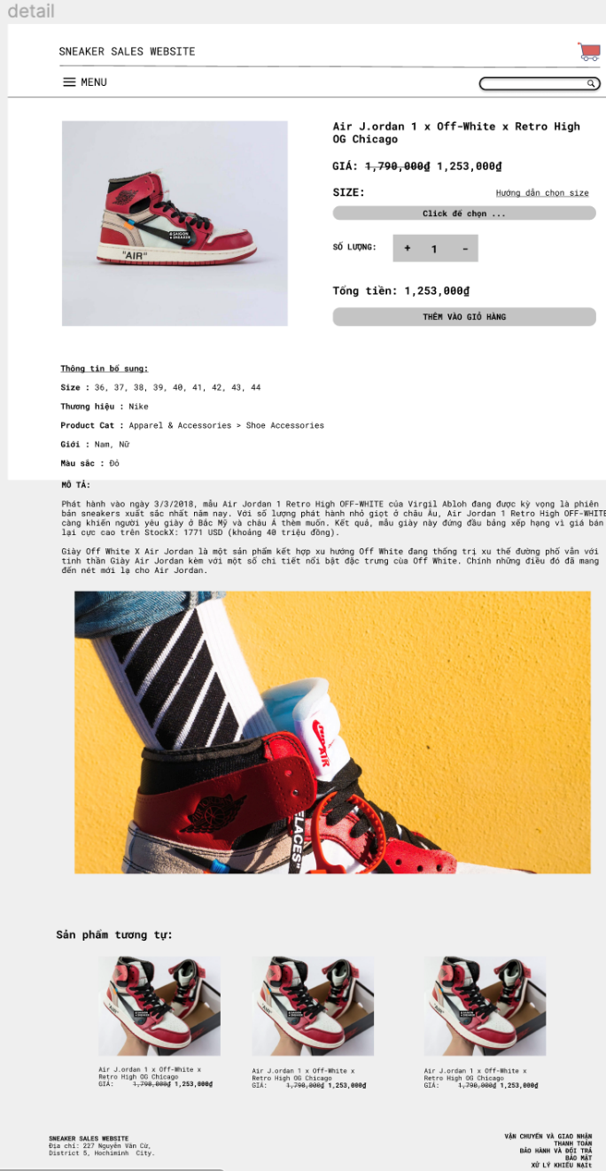

**The purpose:** user can view details of the product and add the product to the shopping cart.

The first part of this page included the product image and add to cart function.

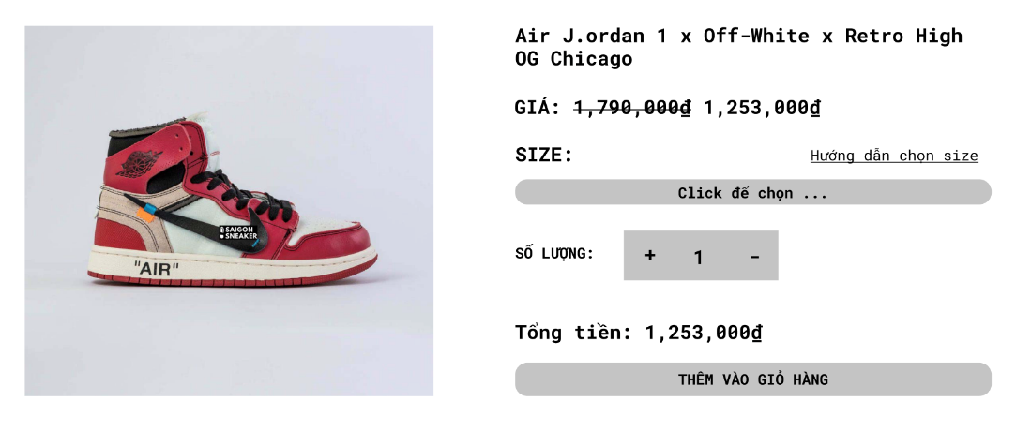

User can change size of the sneaker shoes and the amount of product they want to add to the shopping cart. There will be a link to a web site that show user how to choose the suitable size of the sneaker. The customer can also see the price for each product after apply the promotion and the total amount of money they want to add to the shopping cart.

The second part is some detail information of the sneaker and a mini review or introduction of the sneaker.

The third part is some related production that suggest to the customers.

**ABOUT**

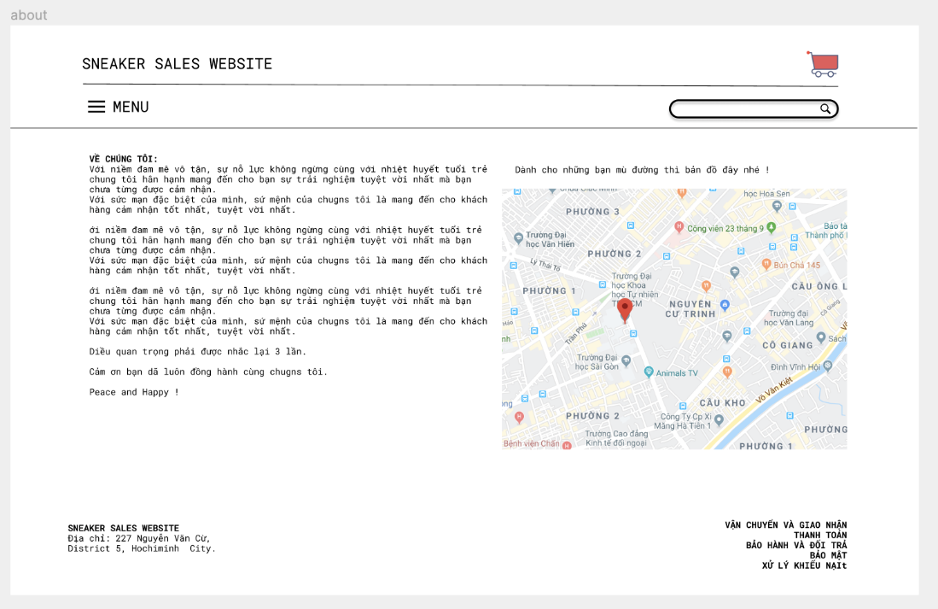

**The purpose:** this page use to introduce some core information of the website to the customers.

User can read the paragraph to get motivate and increase trust in the website.

User can also view a picture of the map to the local store if they want to.

**LOGIN PAGE**

**The purpose:** this page use to login to the webside in order to help customers store point and for manager to login.

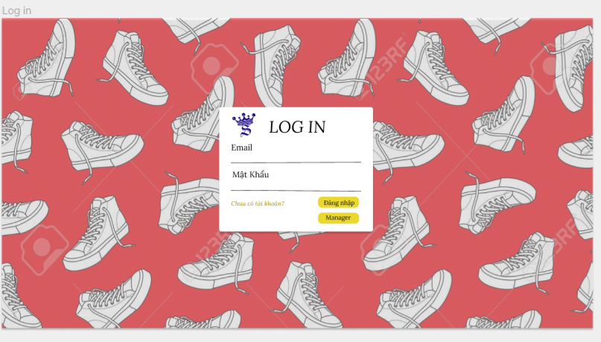

Manager Login

Customer Login

**REGISTER PAGE**

**The purpose:** this page use to register an account to the webside.

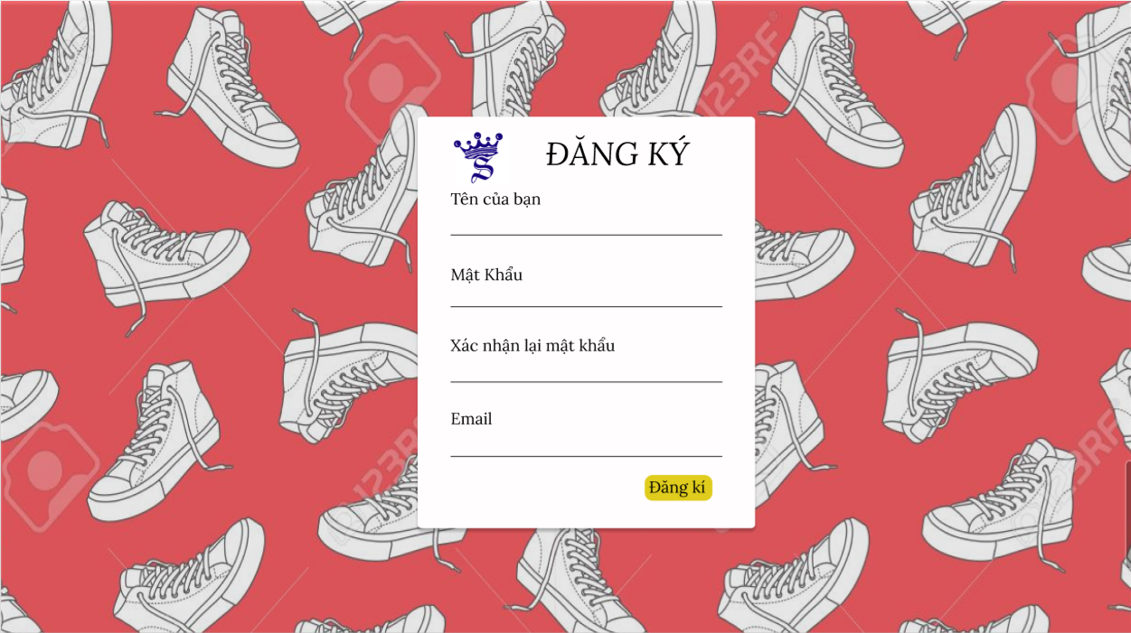

Register

And go back to login page

**ADMIN PAGE**

**The Purpose:** this page is use for manager to manage orders and products.

